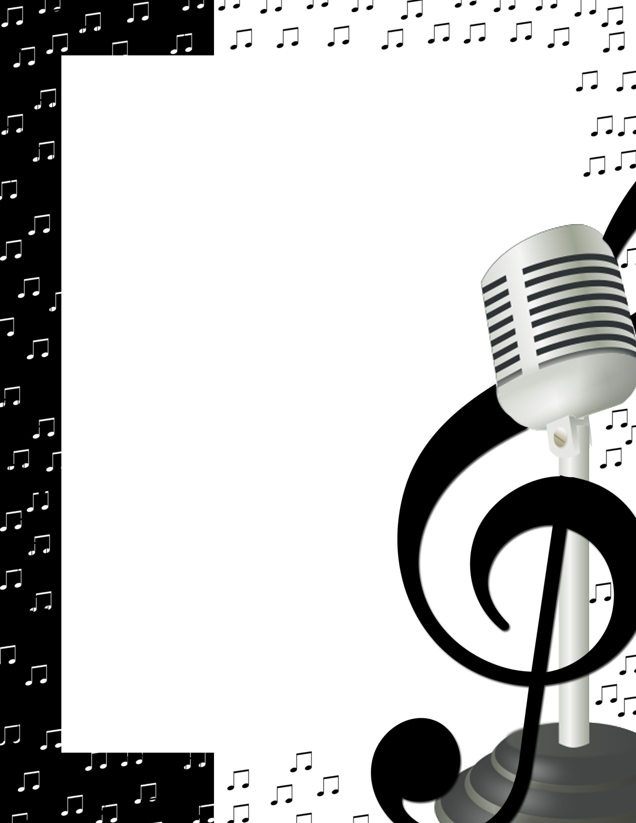
Important Choir Dates
2016-2017
Items marked in bold are required events.

Saturday, September 10, Pre All-State District Rehearsal, Belmond, TBA
Sunday-Monday, October 2-3, UNI Vocal Arts Festival, Cedar Falls, TBA
Saturday, October 8, Real Men Sing! Festival, Waverly, TBA
Monday, October 10, Top of Iowa Conference Honor Choir, Mason City, TBA
Tuesday, October 11, Simpson Honor Choir, Indianola, TBA
Thursday, October 20, High School Fall Vocal Variety Show, 7:00 PM
Saturday, October 22, All-State Auditions, Hampton, TBA
Friday, October 28, High School Musical, 7:00 PM
Saturday, October 29, High School Musical, 7:00 PM
Friday, November 4, Simpson College Voice Clinic, Indianola, TBA
Friday, November 11, NCICDA 7-12 Honor Choir, Mason City, TBA
Thursday-Saturday, November 17-19, All State Music Festival, Ames, TBA
Thursday, December 1, Sheffield K-1 Winter Concert, 7:00 PM
Monday, December 12, High School Winter Concert, 7:00 PM
Sunday-Monday, January 8-9, Dorian Vocal Festival, Decorah, TBA
Monday, January 28, Meistersinger Honor Choir, Waverly, TBA
Thursday, February 9, High School Pops Concert, 7:00 PM
Tuesday, February 21, Youth in Harmony Festival, Humboldt, TBA
Thursday, March 2, Sheffield K-1 Spring Concert, 7:00 PM
Friday, March 3, Franklin Co. Arts Council Concert, Hampton, TBA
Sunday, March 5, Music Boosters Variety Show, Rockwell, 2:00 PM
Thursday, March 23, High School Show Choir Concert, 7:00 PM
Tuesday, April 4, High School Spring Concert, 7:00 PM
Saturday, April 8, State Solo and Ensemble Contest, TBA
Wednesday, April 19-Sunday, April 23, Music Department Trip, TBA
Friday, May 5, State Large Group Contest, TBA
Monday, May 15, Fine Arts Night, 7:00 PM
Wednesday, May 17, Senior Awards Night, 6:30 PM
Friday, May 19, Preschool Graduation, 10:00 AM
Sunday, May 21, Graduation, 2:00 PM
Monday, May 29, Memorial Day Services, TBA

